**Start Prepping Your Wardrobe For Up Coming Festivities**

The pandemic has rooted itself deep but we believe our festive roots are deeper than that. The festive season is here, though we can’t plan a big celebration this year but a little shopping for your wardrobe will do no harm. It will infuse a fresh breath to your collection and will definitely lift your mood up.

## Perfect Outfits For Diwali Evening

After what we have been through this year we all deserve a great Diwali night. So get your wadrdrobe ready for that, pick the prettiest piece you have been you have been dreaming to buy this whole year and if you got nothing in your picklist let us help.

**Festive Suits**

Suit set is the outfit In which you can get a lot of variety with different color options, work, sillhoutees and design element. You can pick kalidar suits with traditionak metallic thread work, straight suit set with sitara work, new Anarkali design suits, trendy sharara and many more styles. We know the time is difficult and you can’t roll around the city and go window shopping before you get the your hands on the best style. The good news is you can adore and shop these styles online and get your order delivered at your doorstep.

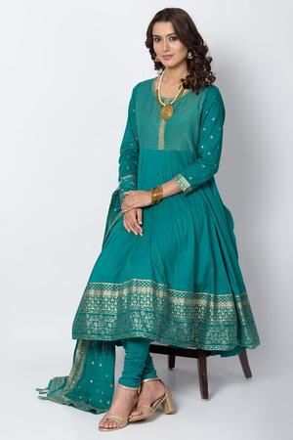 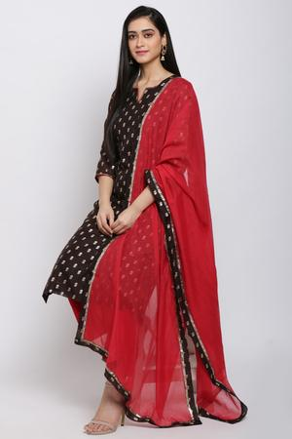 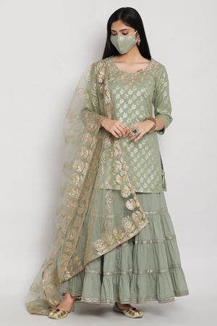 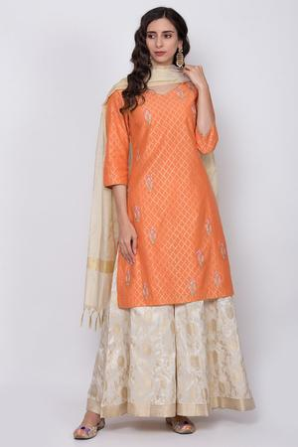

**Festive Suits**

Suit set is the outfit In which you can get a lot of variety with different color options, work, sillhoutees and design element. You can pick kalidar suits with traditionak metallic thread work, straight suit set with sitara work, new Anarkali design suits, trendy sharara and many more styles. We know the time is difficult and you can’t roll around the city and go window shopping before you get the your hands on the best style. The good news is you can adore and shop these styles online and get your order delivered at your doorstep.

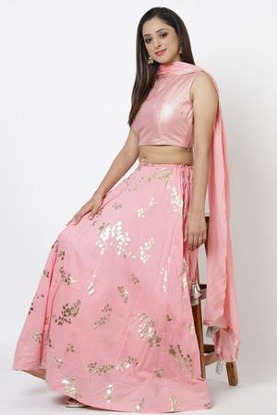 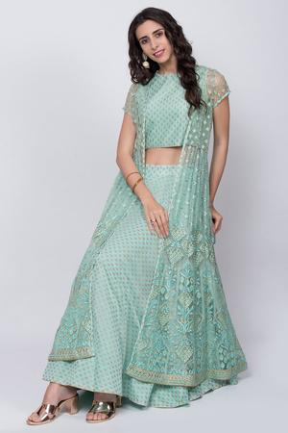 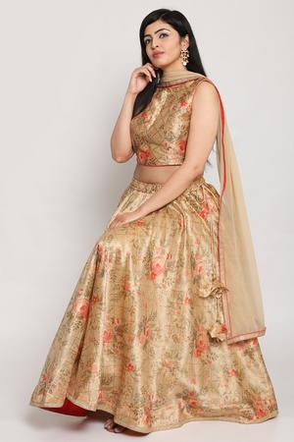 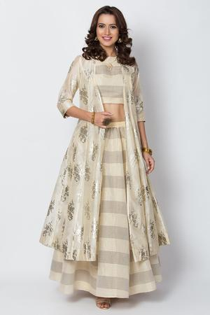

**Festive Lehengas – Contemporary and Traditional Styles**

Lehengas are irreplaceble, there charm is unbeatable. If you don’t like the old tradtioanlw lehengas then the time is in your favor. Market is full of contremporary lehengas, all your have to do is lift your phone and find the best to your taste.

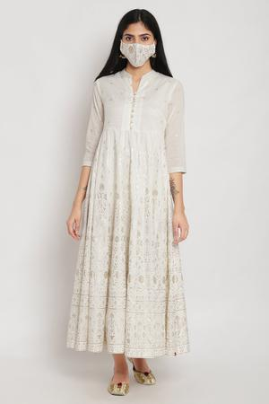 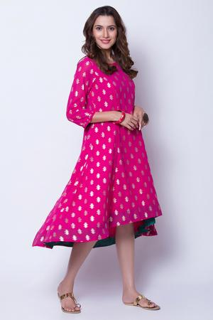 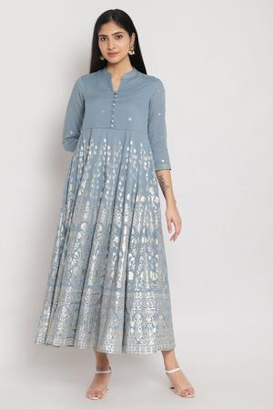

**Meatllic Dresses**

It dresses has got your heart and you if you don’t want to keep them aside even in the festive seaon, then you got to explore the Anarkali dresses in metallic print for your festive wardrobe. The look really look and offers a fuss free look.

**Time For Twinning**

Want to do some festive twining with your little girl? An Anarkali dress for girls is the best idea. You an her both can wear matching colored Anarkali for the festive eve. Kids festive wear is also easily available online and you can shop your loved styles anytime.

|  |  |
| --- | --- |
| https://www.biba.in/new-arrivals/suit-sets/kalidar | kalidar |
| https://www.biba.in/all-suit-sets-kalidar-suit-set | kalidar suit |
| https://www.biba.in/ethnic-wear/anarkali-suit-sets | anarkali dress |
| https://www.biba.in/new-arrivals/suit-sets/anarkali | new anarkali |
| https://www.biba.in/girls/suit-sets/anarkali | anarkali dress for girls |